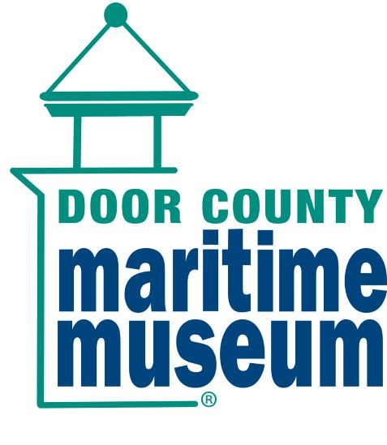
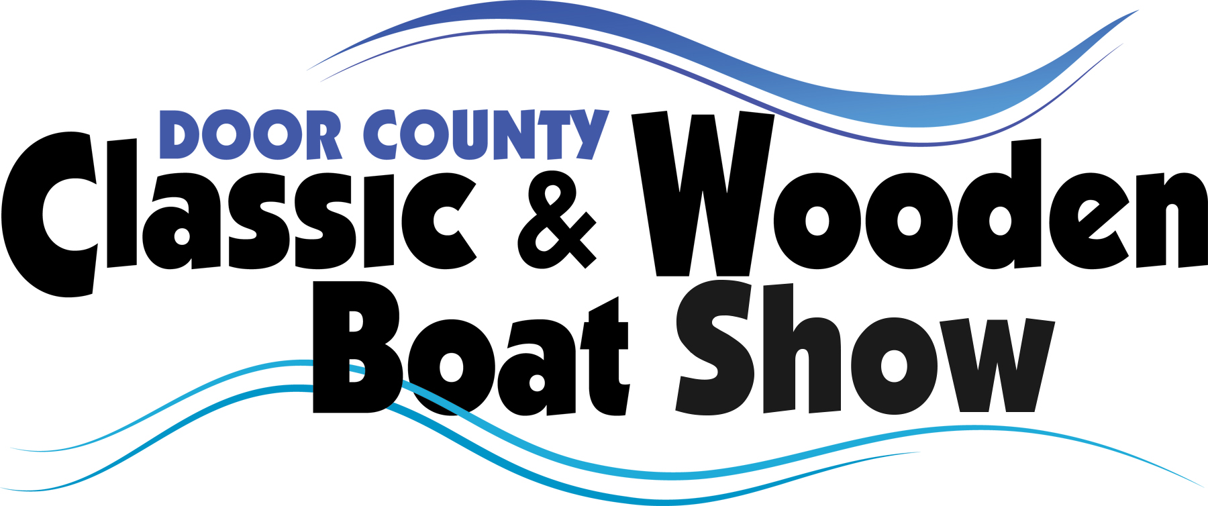

March 15, 2026

Dear Classic Boat Enthusiast,

Thank you for registering your boat(s) for the Door County Classic & Wooden Boat Show, Saturday and Sunday, August 1 and 2, 2026, at the Door County Maritime Museum (120 North Madison Ave., Sturgeon Bay, WI 54235).

CHECK-IN:

- Boats may begin checking in after 8am, Friday, July 31st. Contact us if you need to arrive earlier.
- Check-in at the Boat Show Registration Tent (look for the blue GLACBS tent) as soon as you arrive! You will be directed to your display/exhibit destination and receive your registration packet.
- Your packet will contain your display card(s), two Museum Admission Guest Passes for you to use later in the year, two ID cards with lanyards, and Sturgeon Bay visitors’ information. Please fill in your personal information on the ID cards so other boaters can get to know you. The ID cards and lanyards serve as your admission passes to the museum and tug for the weekend.
- Trailered vessels will be displayed directly in front of the Museum and along the waterfront promenade for easy access and departure, and great visibility. Canoes and kayaks will display on the lawn west of the Museum. Model boats will set up in tents near the Museum. Overnight storage for models is available in the Museum.
- A driving map to the festival site and the nearby Sawyer Park boat launch is available on our website: www.dcclassicboatshow.com The ramp at Sawyer Park is first-class and easy to access. There is a credit/debit payment kiosk located at Sawyer Park Boat Launch for your convenience. The cost for a daily launch is $8.
- Trailers for boats docked at the museum for the weekend may be left at Sawyer Park along the south fence at the back of the parking lot.

DOCKAGE:
- Sea-wall space is limited for larger vessels.
- Your vessel may be docked on the floating dock provided by the City of Sturgeon Bay, the adjoining docks at Snug Harbor Boat Rental or Skipper Bud’s Harbor Club Marina.
- Please ensure you have adequate fenders and line, in the rare case that we must raft another boat off of your vessel.
- We appreciate your flexibility in the shifting of vessels and thank you in advance for your understanding!
- Security is provided from 10pm Friday and Saturday nights until 6am the following morning.

FRIDAY PRE-EVENT FESTIVITIES:
- The 10t^{h} annual Bay to Lake Lighthouse Cruise, Friday, July 31st, begins at 1pm. Enjoy a 10-mile cruise from the Museum to Sherwood Point Lighthouse on Green Bay, then out to Lake Michigan past the Coast Guard Station and Pierhead Light at the east end of the shipping channel.
- At 1pm, meet in the second-floor lobby of the Maritime Museum for a brief Skippers’ Meeting.
- If the weather is favorable, we’ll begin the cruise after the meeting. We will not cruise if small craft warnings are posted. The cruise may be shortened if sea conditions are rough or choppy.
- The Rock & Roll Pizza Party and Cocktails for pre-registered Friday Cruise participants begins after the cruise at 6pm under the large tent at the Museum. It’s a great time to relax and meet your fellow classic boat enthusiasts. Please wear your ID card and lanyard. We encourage you to dress up and compete for the coveted “Most Rockin’” recognition. If you and your crew win, you’ll be rewarded with a gift from the museum’s Death’s Door Mariner’s Store and free registration to next year’s show.

SATURDAY & SUNDAY EXHIBITION DAYS:
- The show is open to the public Saturday: 10am-5pm, and Sunday: 10am-3pm
- Your boat must be present on both days of the festival in order to receive any award or recognition.
- If you display a “for sale” sign on your boat, you must be present on site whenever the “for sale” sign is evident. We will remove “for sale” signs if your boat is left unattended.
- We offer boat rides by volunteer exhibitors. If you’re willing to offer free short boat rides to the public in the downtown area, please contact Bill Freyman. Owners who volunteer, do so on their own. We require all participants to wear life jackets- absolutely no exceptions. There can be no exchange of money, donations, or tipping.
- The Glacier Lakes Chapter of the Antique and Classic Boat Society will provide pop-up tents acting as a “boaters’ lounge” near the trailered boat displays. This area is open to all registrants as a place to escape the sun and to meet other enthusiasts. It is a good idea to bring folding chairs for yourself and crew.
- Saturday evening: three great events. At 2pm on the second floor of the museum, we will offer a guest speaker you’ll certainly enjoy. Don’t miss the presentation. At 4pm on the waterfront behind the Museum, you can attend a concert performed by Door County’s Peninsula Symphonic Band. Come hear their “Salute to the US Coast Guard.” Bring a chair or two. It’s fun.
- Then at 5pm, board your boat and join our Classic Boat Parade through Sturgeon Bay. We take a leisurely route along Sturgeon Bay’s waterfront. Our meeting spot is the basin next to the Museum’s historic tug John Purves. Please arrive there by 5:20.

SATURDAY’S AWARDS:
- People’s Choice: The public will choose one boat to receive a People’s Choice Boat of the Year recognition. They can pick up ballots at the Show Information Tent.
- Awards in all other categories will be decided by you, the registered boaters. Each registered boater will receive two ballots, one for yourself and another for your crew. Please take time to visit all of the boats and recognize those you find particularly interesting. Voting instructions are on the ballots you receive.
- Make sure to place your boat information display cards where they can be easily seen!
- All votes must be cast on Saturday by 5pm. Awards will be presented at 3pm Sunday.
- The Museum staff will choose a Marque of the Year award. This year that award will go to a Fiberglass Boat from the 1950’s or 60’s.

We are all excited about this year’s event and want to thank you for exhibiting. If you have any questions, comments or concerns, please email: dcclassicboatshow@gmail.com or call Bill Freyman at (920) 246-7369. You may also contact Trevor Black at the Museum at (920) 743-5958 or tblack@dcmm.org. During the show, Bill can be reached via his cell at (920) 246-7369.
We’re looking forward to seeing you soon!

Door County Maritime Museum
Classic & Wooden Boat Show Team

